Test ID | Test Description | Test Method | Pre-conditions | Expected Result | Passed? | Comments/Screenshots
1 | Initial output check | Run the program | None | 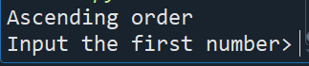 | Yes
2 | Initial User input prompt check | Run the program | Initial output check successful |  | Yes
3 | User input checks | correct value input | Acceptable value inputted into the previous input request | Input the first number> 6  Input the second number> | Yes | 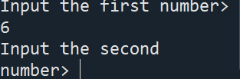
4 | Final output (n1 < n2)check | Run the program | Acceptable value inputted into the previous input requests and correct calculations are done | Numbers were swapped  First number is 4  Second number is 6 | Yes | 